Housestaff Instructions for Joining the IHI Open School

What is the IHI Open School? Check out this video! http://www.youtube.com/watch?v=s_gOFVwZ_64
Briefly, this is a national curriculum on quality improvement and safety that is recognized internationally. You will be able to print your certificates to document your learning in the program and also to add it to your CV to show to employers & fellowship directors. By completing these in advance of our classroom time, it will allow us to use our time together to focus on your project!!
Instructions to register:
- Go to: http://www.ihi.org/education/ihiopenschool/Pages/default.aspx
- Create an account/Register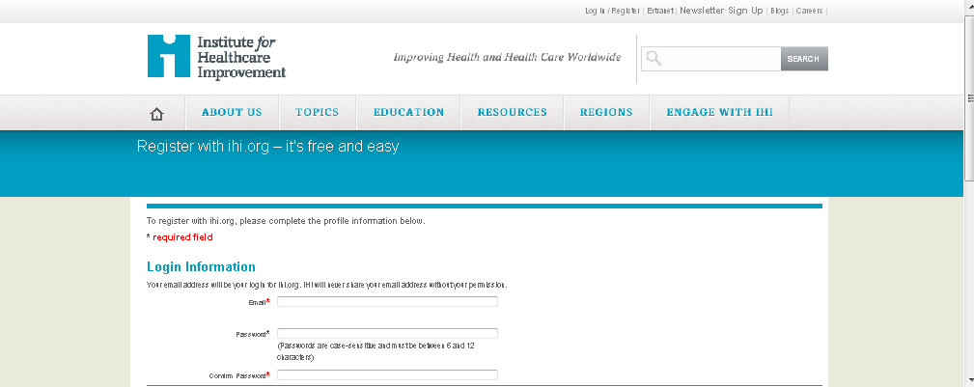
If it asks
  - for the Organizational type: choose Hospital-Teaching
  - For the Organization- Banner Good Sam
  - Under the “private information” select “intern or resident”
- Select: Courses or On the Quick Links (scroll down on the left) “take a course”
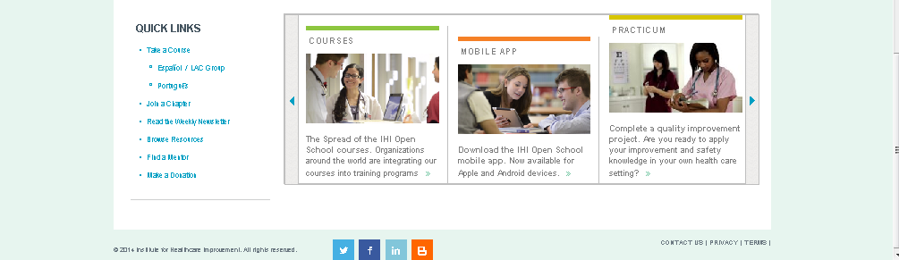
.
- Next click “Academic course” and you will come to this screen
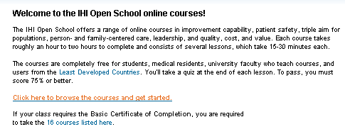
- Scroll down and you will see a lot of fantastic options:
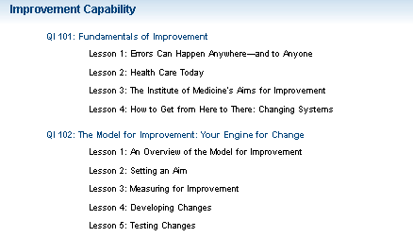
- After you go through the sections and complete the lessons, you can print your certificate: go to “my learning” and then “certificates” and bring them with you to the session.
