The Neuro CCG will be starting a pilot for a Neurogenic Bowel protocol on Jan 2. The protocol was created with direct input from Dr. Geimer and has been approved by Drs. Villanueva, Carstens, Franco, and Agarwal. Since BUMG sees almost every patient within the target units, we need your assistance and support to ensure the proper medications are ordered. With one exception, the medications are on the Bowel Care [cs]. Most of the medications are PRNs. The nurses are currently receiving education on the protocol. They will remind you about starting the protocol, and I will be at rounds for the 6th floor doing the same.

Population: Anyone with a neuro diagnosis on 10BCD, 6B, 6ACD, and Rehab. This is the same definition used for the Neurogenic Bladder protocol. It’s intentionally broad because the identification and diagnosis of neurogenic bowel occurs infrequently.

Intervention: The whole algorithm is divided into 3 parts: Brain, upper spine and lower spine. Each part contains different instructions to manage constipation, diarrhea, and normal bowel movements.
Medications needed:
- Brain
  - Docusate – senna (Senokot S) 1 tab PO, BID
  - Polyethylene Glycol (Miralax) 17Gm, PO, Daily, PRN
  - Lactulose, 20Gm, 30mL, PO, Daily, PRN
  - Bisacodyl suppository (Dulcolax), 1 supp, PR, Daily, PRN
  - Mineral oil (Fleet mineral oil enema), 1 BT PR, daily, enema, PRN
- Upper Spine
  - Senna 1 tab PO, BID
  - Polyethylene Glycol (Miralax) 17Gm, PO, Daily, PRN
  - Mineral oil (Fleet mineral oil enema), 1 BT PR, daily, enema, PRN
- Lower Spine
  - Psyllium (Metamucil), 1 packet, PO, BID

We will be using the Bristol Stool Scale (BSS) to define constipation, diarrhea, and normal. The BSS is an evidence-based assessment of stool consistency: Categories 1 and 2 represent constipation, categories 3 and 4 are normal, categories 5-7 represent diarrhea. The nurse will follow the algorithm below based on an assessment of the patient’s last bowel movement. For example, if the patient has a brain injury the nurse will administer Senna/Colace BID. If the patient has not a bowel movement for 3 days (including time before admission), the nurse follow the instructions in the BSS 1-2 box. Step 1: administer a suppository (bisacodyl) and one dose of Miralax. If the patient has not had a bowel movement in 24 hours, they will then move on to Step 2. If the patient does have a bowel movement, the nurse will assess the patient’s stool according to the BSS. If the stool is “Hard” per Cerner documentation (BSS 1-2), they will return to Step 1 and administer another suppository and dose of Miralax. If the stool is “formed, soft, or pasty” (BSS 3-4) they will give the Senna/Colace BID. If the patient’s bowel movement is congruent with BSS 5-7, they will complete Step 1 under that category: Hold bowel care and reassess in 12 hours.

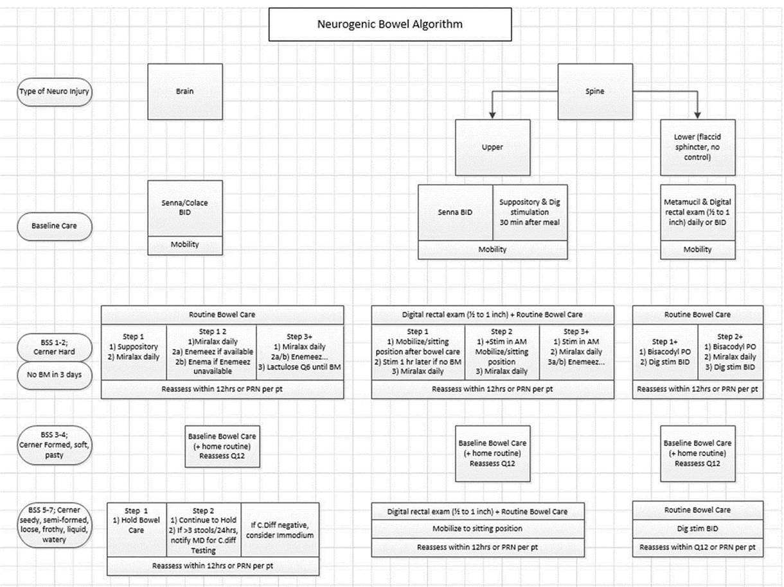

Control group: Data will be collected before and after the protocol is implemented. We are currently collected pre-implementation data, and post-data collection would begin in April.

Outcomes: Our measures are
- Number of days between stools (goal 1 to 3)
- Consistency of stool (goal BSS 3-4). We want to prevent constipation, but do not want to provide too many bowel care medications that the patient has diarrhea.
- Use of Bowel Care [cs]
- Administration of bowel care medications
- Nursing GI assessment

