Housestaff Instructions for Joining the IHI Open School

What is the IHI Open School? Check out this video! http://www.youtube.com/watch?v=s_gOFVwZ_64
Briefly, this is a national curriculum on quality improvement and safety that is recognized internationally. You will be able to print your certificates to document your learning in the program and also to add it to your CV to show to employers & fellowship directors. By completing these in advance of our classroom time, it will allow us to use our time together to focus on your project!!
Instructions to register:
- Go to: http://www.ihi.org/education/ihiopenschool/Pages/default.aspx
- Create an account by choosing the “Log In/Register” at the top of the screen

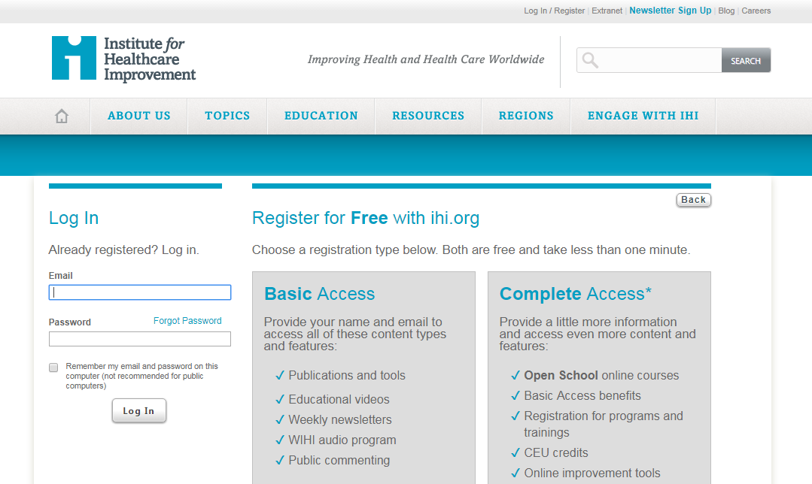

3. REGISTER FOR “Complete Access”
4. Fill out the form with your Banner email address and name information

***It is important to order to not have to pay for this subscription to choose the following:
  - For the Organizational Type: choose Hospital-Teaching
  - For the “Your Organization” input: Banner Good Sam in Phoenix, Az
  - Under the “Personal Contact Information” your Primary Role is “Resident/Intern”
  - Address: 1111 E. McDowell Rd, Phoenix, AZ 85006
Once you have completed the registration form you will be brought to the next screen:
5. Select : OPEN SCHOOL
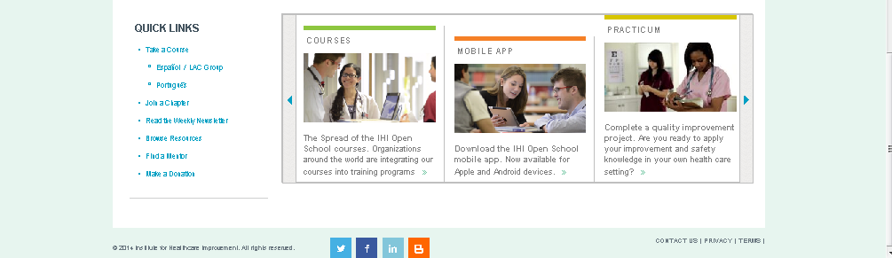
6. Select: Take a course
7. Select the heading “Improvement Capability” or “Patient Safety” depending on what is required from the folders of courses
8. Scroll down and you will see a lot of fantastic options:
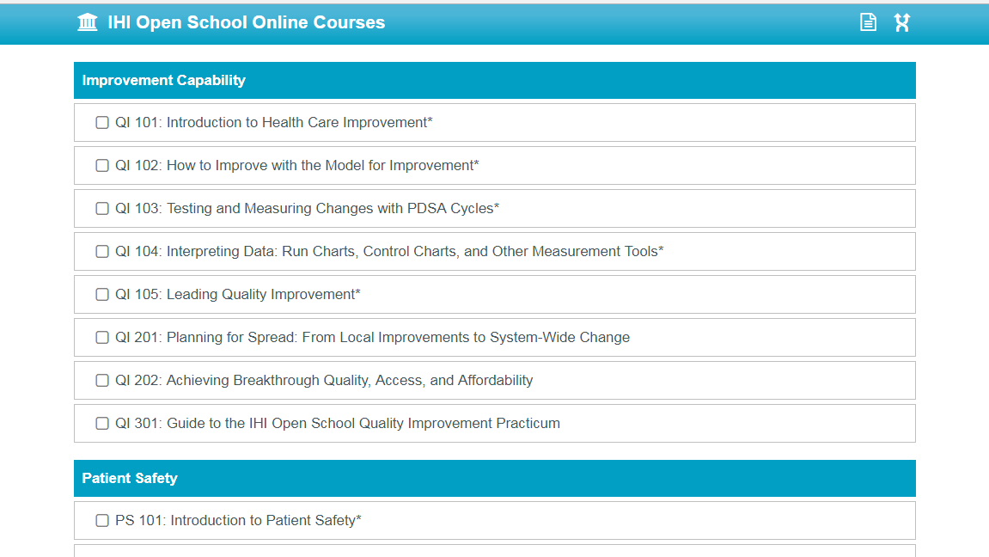
9. After you go through the required sections and complete the lessons, you can print your certificate. At the top of the screen select “My IHI” and then select “My Enrollments and My Certificates” from the right screen bar. Please print your certificates (or email them to Jane Sanborn) and turn them in to Jane Sanborn for credit as these will be tracked for completion.

