21st Annual Academic Excellence Day

Sponsored by

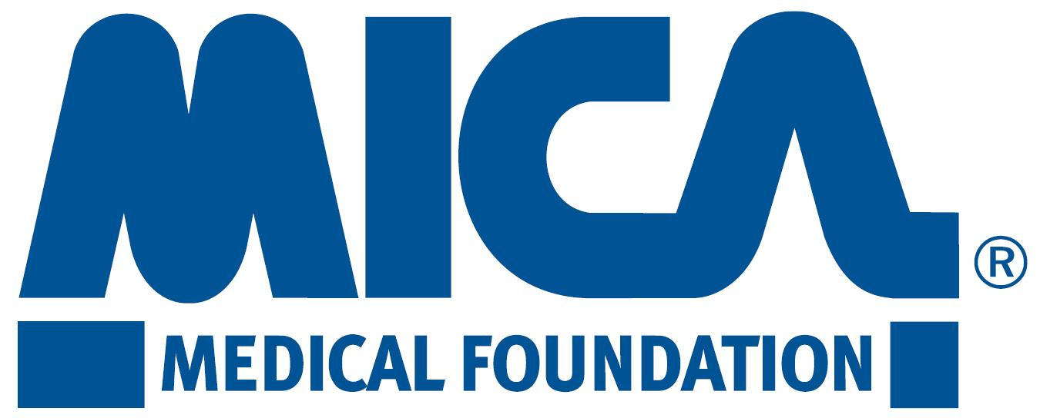

Wednesday, May 3, 2017

LOCATION - The University of Arizona College of Medicine – Phoenix
435 North Fifth Street, Phoenix, Arizona 85004

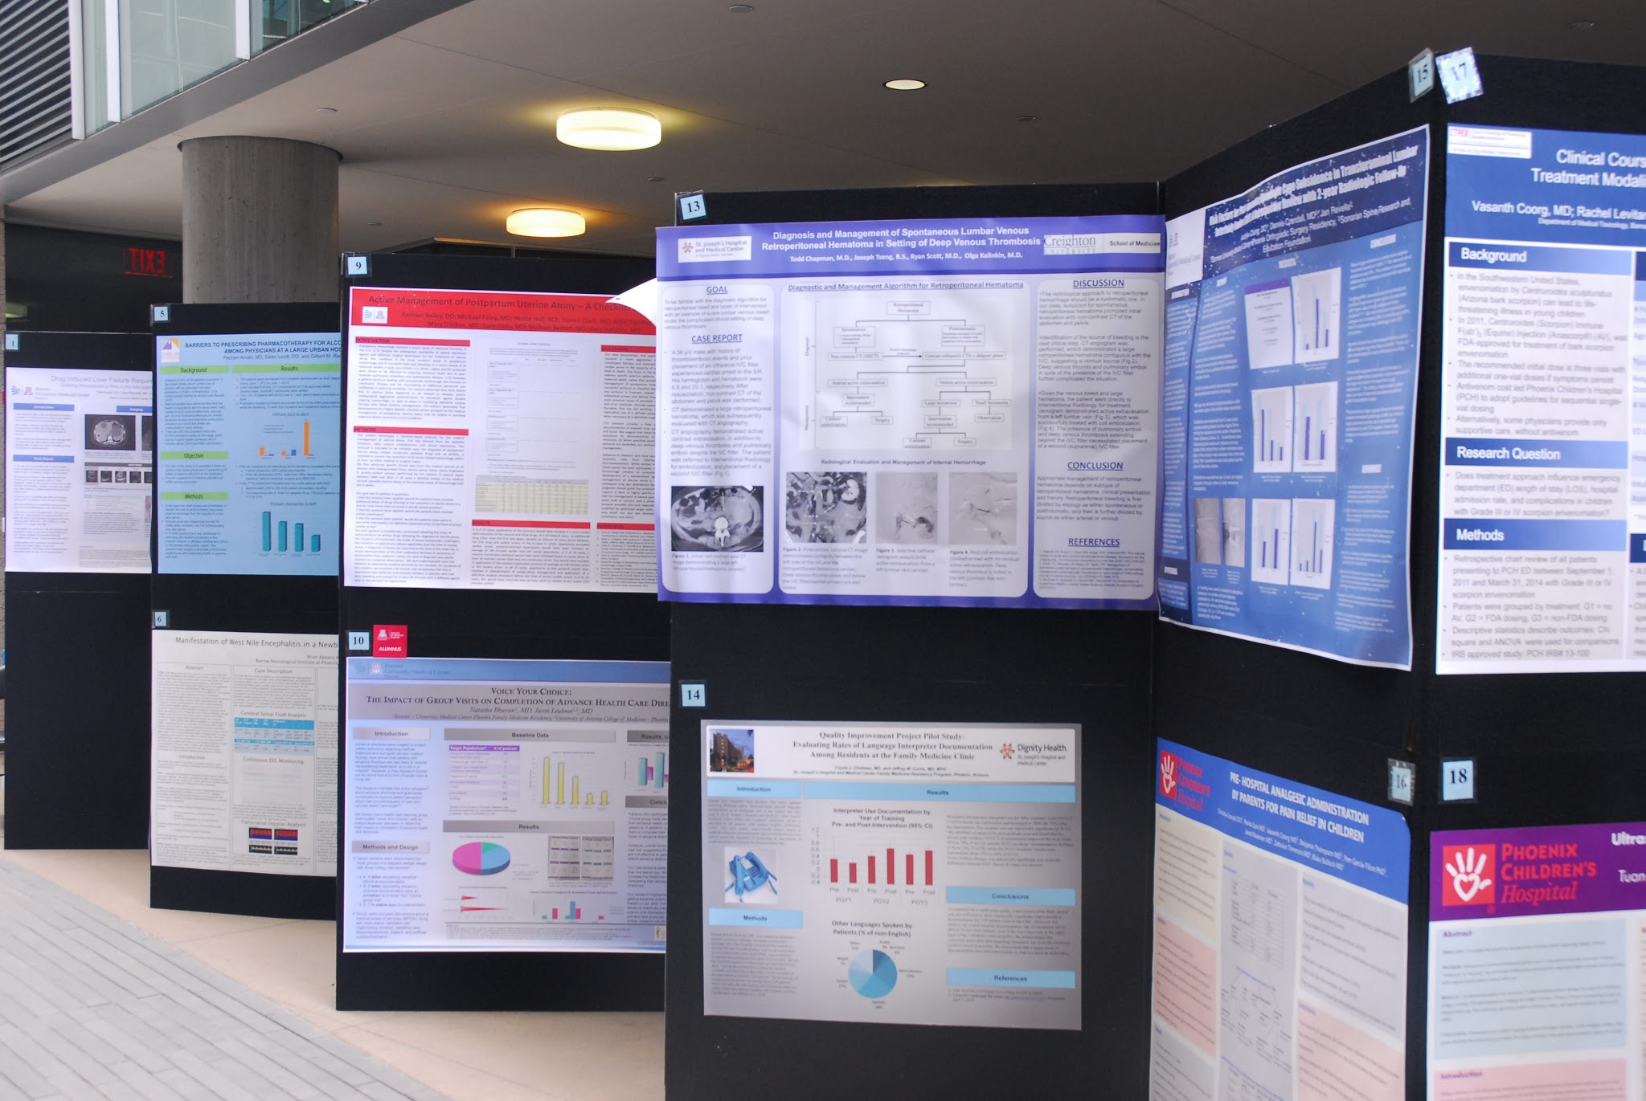

Abstract Deadline

Wednesday, March 8, 2017

ABSTRACT PACKET

2017 ACADEMIC EXCELLENCE DAY – Wednesday, May 3, 2017
ABSTRACT INFORMATION AND INSTRUCTIONS

You are encouraged to write your abstract in a format similar to that used in scientific papers so that it may be cited in curriculum vitae or submitted as evidence of scholarly activity.

Abstract Format - To be considered, abstracts must comply with the following:

- Abstract must be prepared as directed and accompanied by the signed submission form.
- Submit your abstract by one of the following: 1) email, or 2) paper copy with electronic file to Your Contact Person. Macintosh disks will not be accepted.
- Title, typed in ALL CAPS and bolded, should be brief and clearly state content of paper.
- Name of presenting author must be listed first (presenting author can only be a resident or fellow – see “Eligibility” in next column).
- Only abstracts with 1-inch margins (top, bottom, right and left) using Arial 11 pt font will be accepted.
- The abstract must be single spaced, left justified, and must not exceed 1 page in length (8-1/2”x11”).
- Ensure that all changes are accepted, turn off track changes, and spell check before submitting abstract.
- Do not make reference to institution unless it is different than the institution submitting the abstract.
- Signature of program director is required on the submission form.
- All abstracts must be submitted as one document from the institution, organized alphabetically by the last name of the first author.
- Photos in the abstract are acceptable.

The body of the abstract MUST be organized as follows (see attached examples):

Research Case
- Purpose 1. Introduction
- Methods 2. Case Report
- Results 3. Discussion
- Conclusions

Style: Write for clarity and directness. Avoid use of medical jargon and empty stock phrases. A table or figure may be used if it fits within the parameters; pictures will appear in black and white. Grammar and punctuation will be taken into consideration. Please proofread your abstract. If accepted, the abstract will be published in the program exactly as submitted.

Abbreviations, symbols and nomenclature - Usage should conform as closely as possible to that recommended in the AMA Manual of Style: A Guide for Authors and Editors (9th edition, 1998). Keep nonstandard abbreviations to a minimum. Generic names of drugs are preferred. A proprietary name may be given only with the first use of the generic name. Please use the International Union of Pure and Applied Chemistry preferred concentration units for clinical measurements.

Eligibility - For poster and oral presentations: residents and fellows only. Previously published abstracts may be used if published between January 1, 2015 and February 1, 2017.

Number of Entries - An author may submit as many abstracts as he/she desires; however, only one abstract per author will be selected. All abstracts submitted and accepted for poster presentation must have a poster ready for printing on April 24.

Acceptance - A panel of judges will review abstracts and notify those selected for oral and/or poster presentations during the second week of March. Notifications will include detailed instructions for oral and poster preparation.

Institutional Review Board (IRB) – Many research projects will need to be approved by your IRB. If you are submitting an abstract please make certain you have approval from your IRB. Please attach a copy of the IRB approval along with your abstract. See attached memo for IRB Guidelines from your institution.

Prizes - A panel of judges will evaluate all presentations. Presentation of awards will take place at a reception at the end of the day. One-year fellows are eligible to submit case report posters, and two plus-year fellows are eligible to submit research abstracts ONLY for posters or oral presentations. Otherwise, there are separate awards for residents and fellows.

For oral presentations:
Clinical Research: First Place: $325
Second Place: $225
Third Place: $175
Case Report: First Place: $225
Second Place: $175

For poster presentations:
Clinical Research: First Place: $225
Second Place: $175
Third Place: $125
Case Report: First Place: $125
Second Place: $100

In addition, all oral and poster presenters will receive a certificate recognizing their participation.

ABSTRACT DEADLINE

Wednesday, March 8, 2017

ACCEPTANCE NOTIFICATION
Second week of March.

SUBMIT ORIGINAL ABSTRACT TO: Richard.gerkin@bannerhealth.com
Attachments: Abstract Samples
Institutional IRB Guidelines

2017 ACADEMIC EXCELLENCE DAY
WEDNESDAY, May 3, 2017
SUBMISSION FORM
PRESENTATION TITLE:

AUTHORS: (PRESENTING AUTHOR LISTED FIRST)
SUBMISSION DEADLINE
Wednesday, March 8, 2017

YOUR CONTACT INFORMATION HERE

Follow format outlined on the Abstract Instruction Sheet and submit one of the following:
(1) E-mail with attachment using Microsoft Word to: Richard.gerkin@bannerhealth.com

Check one of the following:
Research Project
Case Report

Check one of the following:
Oral Only (Residents/Fellows)
Poster Only (Residents/Fellows))

For studies receiving IRB approval, there needs to be a statement on the poster or in the PowerPoint presentation regarding IRB.

Print/Type Contact Name:_______________________________________________________________

E-mail Address:_____________________________________________________________________

Institution Name: ______________________________________________________________________

Program: ____________________________________________________________________________

Cell Phone: _____________________________________ Pager: _____________________________

Approval Signature: (Program Director or Clinical Chair): ______________________________________

Guidelines for IRB review
For Academic Excellence Day

In the preparation of the abstracts for posters and presentations for Academic Excellence Day, the following guidelines are provided to help residents and their mentors to determine whether IRB approval is needed for the project being submitted.

Types of studies that do not need IRB review

- Case reports; Case series
- Meta analyses using published literature
- Reports using publicly available databases (e.g., CDC, Maricopa County Public Health Database)

Types of studies that do need IRB review (review and approval should occur before any data collection begins)

- Studies based on medical record review (any EHR or departmental database that collects PHI about patients)
- Interviews/surveys if identifiers are included. If anonymous, these may be exempt from continuing IRB review but investigators/residents should consult with the IRB to get official evaluation of whether it is exempt.
- Educational program assessments (programs for healthcare professionals as well as for patients/families)
- Outcome studies
- Studies of practice patterns if PHI or other confidential information sources are used
- Observational studies collecting new data about patients
- Interventional or treatment protocols

PARAPLEGIA IN A 4 YEAR-OLD GIRL FROM POST-TRAUMATIC HYPERTENSIVE SYRINX: A CASE REPORT

Scott Swanson, MD, Bonnie Strohschein, NP, and Carlos Carrion, MD

Introduction: Syringomyelia is a disorder in which a fluid filled cystic cavity develops within the spinal cord, leading to an entity commonly known as a syrinx (NIND). Syringomyelia is further classified into two separate forms of the disease. The first being associated with Arnold-Chiari type I malformation with subsequent formation of a cervical syrinx, referred to as communicating syringomyelia. The second classification of the disease occurs as a result of trauma, meningitis, hemorrhage, tumor, or arachnoiditis. In the latter case, a syrinx expands at the site of injury, commonly referred to as non-communicating syringomyelia (NIND). The incidence of post-traumatic syringomelia in patients with documented spinal cord injury, manifested as subsequent paraplegia or tetraplegia, is estimated to be 4.45%. The time of presentation of symptoms from initial period of injury ranges from 2 months to 30 years. We report a case in which onset of symptoms from post-traumatic syringomyelia was less than 48 hours.

Case Report: A 4-year-old female arrived at a medical facility within thirty minutes of becoming entrapped between the garage wall and a car driven by another child. On arrival, she presented with a GCS of 15, and had a non-focal and unremarkable neurological examination. The child did have mild abdominal tenderness that was diffuse, but lacked rebound tenderness or guarding. In addition she had facial petechiae, from presumed traumatic asphyxia. A CT of her abdomen and pelvis was remarkable for a grade III liver laceration. A CT of her head was unremarkable. Her exam on arrival to MMC was without any notable change. A repeat CT head and C-spine were unremarkable. She was admitted for observation to the PICU. While being observed in the PICU, she required Coud’e catheterization twice. Approximately 36 hours after her arrival at MMC, she was noted to have flaccid lower extremities and lacked the ability to move her lower extremities. In addition, she lacked sensation to light touch and pinprick sensation to the level of T4 on the left side of her body and T5 on the right. This prompted immediate neurosurgical consultation and prompted radiographic evaluation per MRI with and without contrast, attributing the most likely event to be a venous infarct or a spinal artery occlusion. The patient was promptly given an IV dose of methyl-prednisone for new onset spinal cord injury. Review of the MRI demonstrated a syrinx present from T1-T12, with the widest portion present at T8-T9. The child was subsequently taken to the operating room for the placement of a syrinx-externalized drain to relieve expansion of the syrinx. The drain was placed at the widest portion of the syrinx, and then drained from the thoracic incision to an externalized collection bag. The post-operative course demonstrated the patient’s ability to regain sensation to the level of T8-T9. She still remained without the ability to move both of her lower extremities, lacked rectal tone, and required a Foley catheter to remain continent. The syrinx to externalized drainage source was placed in the peritoneum and there continued to be CSF fluid draining from the catheter. Post-operative MRI images confirm the collapse of the syrinx within the spinal cord.
Discussion: Sudden onset of complete paraplegia and sensory loss of a neurologically intact patient occurring within 48 hours of injury draws attention to this case. Upon diagnosis of syringomyelia, prompt placement of a syrinx-externalized drain to relieve expansion of the syrinx reversed some but not all symptoms.

LOOP ELECTROCAUTERY EXCISIONAL PROCEDURE AND COLD KNIFE CONIZATION POST TREATMENT FOLLOW-UP: A COHORT STUDY

Michelle Faubion, MD, David Greenspan, MD, Dean Coonrod, MD, MPH, Kim Ward Hart, MA, Kathleen Mathieson, PhD

Purpose: While there is evidence that loop electrocautery excisional procedure (LEEP) is as effective as cold knife conization (CKC) in recurrence of cervical dysplasia, follow up recommendations and time to follow-up may be affected by the type of excision procedure done. The purpose of this study was to examine follow-up recommendations and time to follow-up in a group of low-income primarily Spanish speaking patients undergoing in-office LEEP and in-hospital CKC for cervical dysplasia. An additional aim of the study was to identify and describe demographic variables predictive of compliance with follow-up post LEEP and CKC.

Methods: Between January 2001 through January 2003, 135 women were identified who underwent either a CKC or a LEEP for cervical dysplasia. A retrospective chart review was performed with collection of longitudinal follow-up information. All patients from the women’s care clinic at Maricopa Integrated Health System (MIHS) who underwent a LEEP or CKC during this time period were included. Using these criteria, 134 women were identified for inclusion in the study. Data was collected on whether the recommended follow-up occurred and the time to follow-up. Patients were followed for one year from the date of their procedure. Those without follow-up one-year post procedure were defined as non-compliant. Those cases with the recommended follow-up in the one-year time period were considered compliant. Potential stratification variables included: degree of dysplasia, payer source and practitioner giving the follow-up instruction. Analyses were performed using chi-square tests, Mantel-Haenszel, and logistic regression.

Results: The 135 patients were predominately Hispanic (78%) and 45.9% spoke only Spanish. The main payer source was AHCCCS (71%). Of the 135 patients, there were 81 LEEPs (60%) and 54 CKC (40%). The majority of patients presented for their postoperative visit (86.7%); however a greater percentage of those that had CKCs presented for their postoperative visit (92% versus 82%). Those patients that had CKCs were significantly more likely to be compliant with follow-up than those patients who had LEEP procedures (p<0.001), regardless of the degree of dysplasia, payer source and practitioner giving follow-up instructions. Overall, those patients who presented for their postoperative visit were more likely to follow-up as recommended within the year regardless of the type of procedure performed.

Conclusion: Patients who underwent LEEPs were less likely to be compliant with follow-up than those who underwent CKC procedures. This suggests that patients may perceive their condition as less serious if they had an in-office procedure, and therefore do not understand the importance of close follow-up. Presentation for post-operative care was a significant predictor of compliance; emphasizing the importance of this visit may be a useful strategy to improve long-term compliance.

