**PROVIDERS**

**Restraint Management -** [Restraint Toolkit](http://intranet.bhs.bannerhealth.com/NR/exeres/8A3A003E-66B7-46F8-BD17-A45DB8841DD8%2cframeless.htm?NRMODE=Unpublished&WBCMODE=PresentationUnpublished&wbc_purpose=Basic)

Restraint documentation is updated. Highlights include:

* Two new PowerPlans for violent and non-violent restraints



* New Face to Face Form: Discern alert with link to new Restraint Face to Face form

## **Cardiology Related Documentation Location Change in Clinical Notes**

To improve the findability of cardiology related documents within clinical notes, six folders will be moved from Operative / Procedure Reports to Cardiopulmonary Reports on August 8th. This move will change the location of historical and new documents of the types below.

|  |  |
| --- | --- |
| Document Name | New Location on 8/8 |
| Cardiac Catheterization Report | Cardiopulmonary Reports |
| .Cath Lab Pre-Op Check | Cardiopulmonary Reports |
| .Elect PreProced Pacemkr Defib Rec | Cardiopulmonary Reports |
| .ICD Criteria Checklist | Cardiopulmonary Reports |
| .ICD Registry Data Collection Form | Cardiopulmonary Reports |
| .Pre-Call Nursing Record CTA Cardiac | Cardiopulmonary Reports |

**ED High Utilizer**

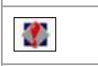New icon to identify patients that are frequent visitors to the ED and Hospital. LaunchPoint alert will appear in room column, and Tracking board will have new icon

* ED High Utilizer: 3 or more emergency encounters within 26 weeks
* Hospital High Utilizer: 3 or more Inpatient encounters within last 52 weeks

**ED 24 Hour and 48 Hour Returns**

* Already have 72-hour return. Adding 24 and 48 hours return to the ED
* Will appear with icons

**ED Updated Powerplans**

* ED COPD
* ED Asthma

**ED Tracking Board Icons Update**

Icons are being updated with LaunchPoint implementation

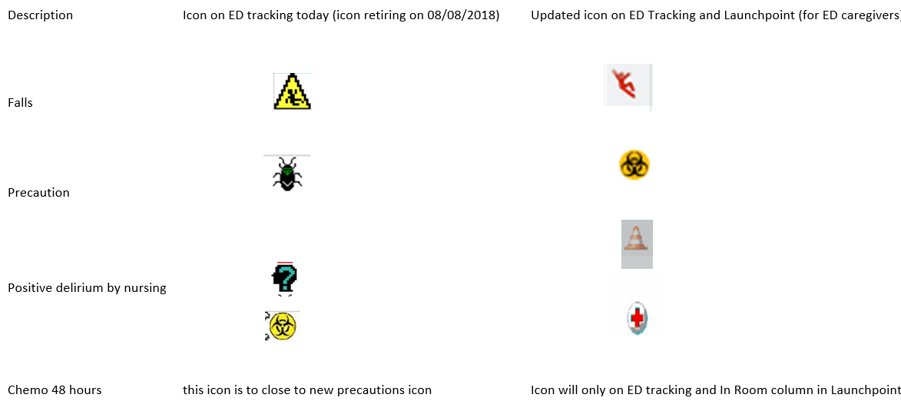

**ED Real Time Dashboard Update**

**Under Pending tracking events adding and updating order they display:**

* Admit Clearance: patients with “ED potential admit or observation communication” orders
* Admit: patients with “Admit to Inpatient” or Place in Observation
* Discharge: patient with “ED Discharge to” orders
* Transfer Clearance: patients with “Patient Transfer Services Request” orders
* Transfer: patients with “ED transfer to another facility” orders
* This helps to get a quick glance of the status of ED patients. As we prepare to reduce ED tracking on 10/17/18 this will fill gap with Admit/transfer tracking tab being retired

***Click on upper right corner arrow to see patient specific information. Must be logged into FirstNet and checked in as an “available provider” to open arrow. ***

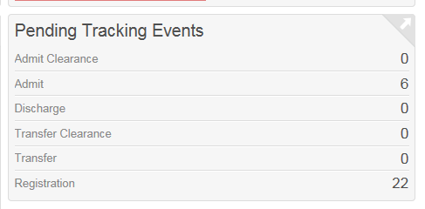

**LAB**

**New Reference Laboratory On-line Test Information (JDOS)**

**Who:** All Physicians, Nursing, Medical and Laboratory Staff

Laboratory Sciences of Arizona is providing notification that a new online test catalog is now available on the Banner Intranet. The Joint Directory of Service (JDOS) has been created in partnership with Quest Diagnostics to provide a laboratory directory specific to each Banner facility.

To ensure quality and turnaround time of results performed by reference laboratories we are providing the specimen information link for accurate specimen collections. This link can be accessed by entering it directly into the URL: <https://jdos.nicholsinstitute.com/dos/BUMCP> or you may also access the link from the Banner Intranet at:

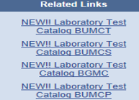

**Pharmacy**

**mCDS Alert Optimization**

* Providers can choose to filter duplicate therapy and drug-drug interaction alerts by choosing the override reason of **“Provider Encounter Filter”** in the mCDS window. Alerts for those drugs will no longer fire on that encounter for that specific physician.

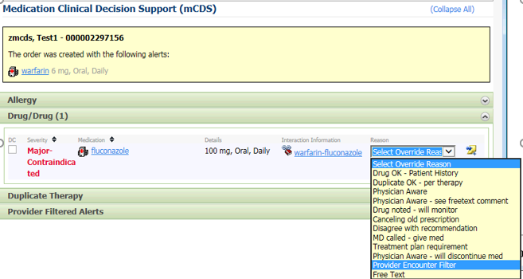

* Decrease the number of clinical insignificant mCDS alerts, to simultaneously decrease the magnitude of user alert fatigue and improve the user ability to critically evaluate drug therapy when significant interactions occur
* [mCDS Tipsheet](https://collaboration.bannerhealth.com/clinical/CareMgmt/BHCorp_CM/CareTransformation/CITipsheets/New%20Hire%20Documentation%20Assistance/2.0/Banner%20-%20mCDS_End_User_Flier.pdf)

**Pharmacy Med Labels**

**When:** Go-live planned 8/8 – 8/15 pending completion of testing. Additional information will be sent out once timeline for label conversion finalized.

* All critical components for the labels are displayed for the various medication types
* All superfluous information is removed (i.e. expiration date/time for oral medications should not display on the label)
* All ingredients display on the label for multi-ingredient medications

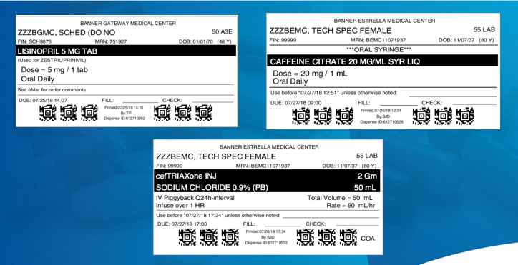

**Medication Order Entry Format Changes**

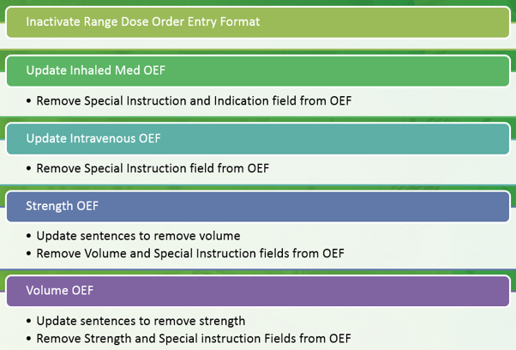

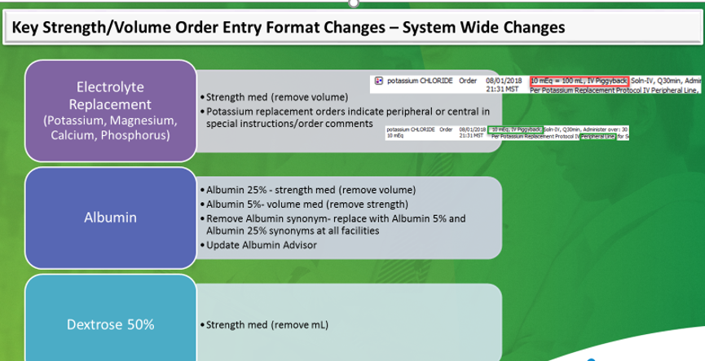

**Prescription Printing/Reprinting**

